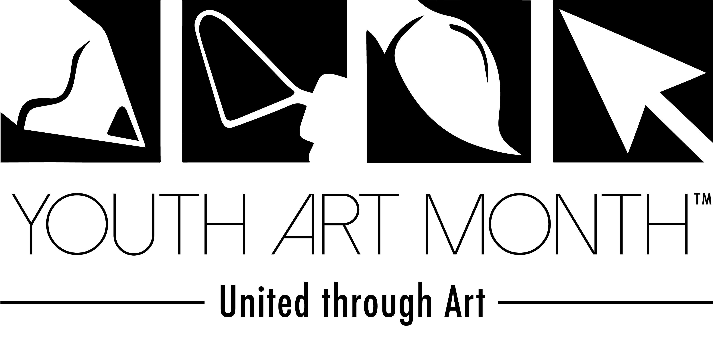
2017 Youth Art Month Flag Entry Form
Mail Entries (and a self-addressed stamped envelope if you want them returned) to:
Jess Beach
550 Alwington Blvd
Warrenton, VA 20186

Postmarked by December 14th
The winning Virginian design will be made
into a 3 x5’ flag and be displayed at the
NAEA Convention in New York, New York.

Winners will receive a poster of their design, award, and a personal
letter from the VA YAM Chair.
Directions:
Boldly and creatively use any 2D art supply (crayons, markers, colored pencils, paint, pastels, etc.) to incorporate the YAM logo (above, left corner), imagery to represent Virginia, imagery to represent art and the theme “United through Art.” Remember to think about your composition and craftsmanship. Entries may be either vertical or horizontal in composition. Only design in the rectangle below.
Student Name___________________
Division
- Elementary School
- Middle School
- High School
Grade____
School _________________________
School Address__________________
_______________________________
_______________________________
Art Teacher_____________________
Art Teacher Email________________
_______________________________
VAEA Region
- Northern
- Southwest
- Blue Ridge
- Tidewater
- Central
District _________________________

