Virginia Art Education Association
To promote, support and advance visual arts education through professional development, leadership, research and service.

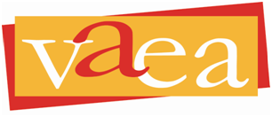

Dear,

I would like to first thank you for your support of the arts in____________. I know that you stand with me and share in my belief that the arts provide a limitless benefit to all of our students, especially during these challenging times.

As you plan for school this fall, I encourage you to keep the arts an integral part of K-12 education and to ensure that all of our students have access to the subjects that are so very valuable to their lives in school and beyond.

Here are what I consider to be important reasons to include a vibrant arts program when planning for the fall:

- The Virginia fine arts Standards of Learning are naturally equipped to be delivered virtually through distance learning methods and provide students a needed outlet for expression during vast changes in routine.

- The arts are a natural fit with social and emotional learning (SEL). Arts educators are uniquely suited to help students implement SEL competencies through real-world practice.

- The Code of Virginia states that the fine arts must be part of all K-12 instructional programs. We believe this should not be waived.

- Many students are on a pathway to a career in the arts. Limiting instruction could have irreversible effects on skill competencies and life plans after graduation.

I thank you and your team in advance for keeping the arts as part of any adjusted plan for the fall. Please feel free to reach out with any additional questions

Sincerely,

