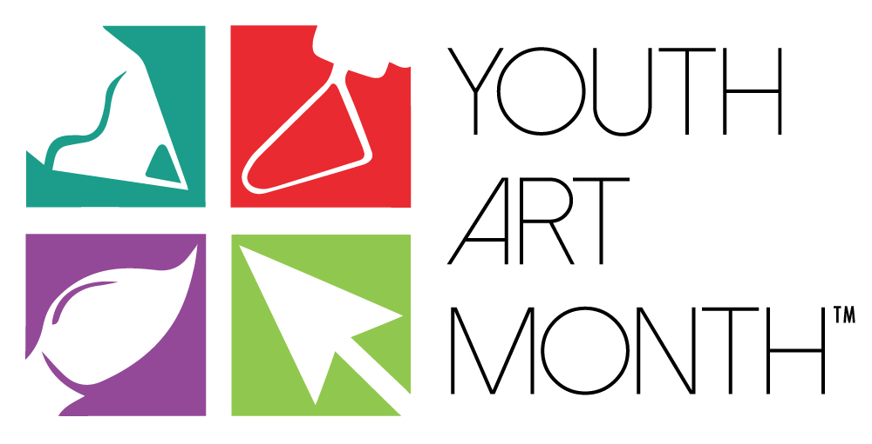
Virginia Youth Art Month Documentation Report

*Please fill out any portion of the form that applies.*

Please include as much documentation as possible, such as photographs, newspaper articles, web postings, etcetera so that this information can be used in the state portfolio. Attach additional pages as needed.

Contact Name: Title:
District/County:
Contact Email:

Proclamations and Endorsements:
Position of signatory | Name of Signatory | Type of Proclamation | Date

Funding for Youth Art Month:
Monetary Amount  (Estimation) | Funded by | Event/Materials the funds supported

Improvements:
Were there any significant changes in your YAM program this year? Number of artworks in exhibits, number of participants in YAM flag competition, increased art shows or endorsements, new awards offered, use of technology to promote YAM

Participation:
Name schools in your district/county that participated in any Youth Art Month activities

What percentage of your division’s schools participated in any Youth Art Month activities? %

What number of students participated in:
Individual school exhibits *combined number of any participating schools
Regional exhibits
District exhibits

Was this an increase, decrease or comparable to last year?

Awareness and Community Support:
List any: partnerships and/or events with libraries, art centers, museums, etc. Donated products, gifts, giveaways, monetary donations from local businesses, new awards or participation, sponsorships- free admission, gift cards, gift certificates, signage, food for events, free space rental
Item/Space/Award | Participating Partner

Promotion:
Name of Print Media | Local or Statewide | Date | Subject | Photo included | Article Length

Web/Social Media Coverage:
Website Address | Subject | Photo included | Article Length

Radio/TV Coverage:
Observance | Participants | Location | Date

YAM Exhibits/Events:
Location | Date | School, Division, Regional | Explanation of Event including the number of attendees and student participants

Special Materials:
Examples include: posters, postcards, buttons, banners, promotional items, registrations forms, award certificates, programs for events, thank you notes, surveys, reminder cards/emails
Type of Material | Date Made | Description | Made by

The portfolio and this Virginia Youth Art Month Documentation Report can be submitted either digitally to jmbrooks@harrisonburg.k12.va.us or a hard copy mailed to: Jauan Brooks, YAM Co-Chair, Harrisonburg High School, 1001 Garbers Church Road, Harrisonburg, VA 22801

